|  |
| --- |
| **Remarque préalable**  Les exercices de TDs que vous allez découvrir sur la plateforme sont uniquement sous forme de QCM.  Ces QCM sont de deux natures :   * QCM de cours : elles reprennent le contenu du cours. Pour parvenir à répondre à ces questions, vous devez étudier les documents du cours. * QCM sur les cas d’étude : un ou plusieurs cas d’étude sont proposés dans des documents portant le nom de « **Text-TDxx** ». Ces QCM feront toujours références au numéro de cas d’étude « xx ». |

# Third lecture (Ch 3)

## No. 1 : IKEA

With over 210 giant stores operating in more than 30 countries, and sales of around €15 billion, IKEA sells ‘a wide range of well-designed, functional home furnishing products at prices so low that as many people as possible will be able to afford them’. This IKEA Concept ‘guides the way IKEA products are designed, manufactured, transported, sold and assembled, or, put another way, it guides all aspects of its operations management’.

The name IKEA comes from the initials of its founder, Ingvar Kamprad, I and K, plus the first letters of Elmtaryd and Agunnaryd, which are the names of the farm and village where he grew up. In the 1950s Kamprad, who was successfully selling furniture through a catalogue operation, built a showroom in Stockholm. Not in the centre of the city where land was expensive, but on the outskirts of town. Rather than buying expensive display stands, he simply set out the furniture as it would be in a domestic setting. Instead of moving the furniture from the warehouse to the showroom area, customers pick up the furniture from the warehouse themselves. The furniture is usually designed to be stored and sold as a ‘flat pack’ which the customer assembles at home. The stores are all designed around the same self-service concept – that finding the store, parking, moving through the store itself, and ordering and picking up goods should be simple, smooth and problem-free. At the entrance to each store are large notice boards which proclaim IKEA’s philosophy and provide advice to shoppers who have not used the store before. Catalogues are available at this point showing product details and illustrations. For young children, there is a supervised children’s play area, a small cinema, a parent and baby room and toilets, so parents can leave their children in the supervised play area for a time. Customers may also borrow pushchairs to keep their children with them.

Parts of the showroom are set out in ‘room settings’, while other parts show similar products together, so that customers can make comparisons. IKEA likes to allow customers to make up their minds in their own time. If advice is needed, ‘information points’ have staff who can help. Every piece of furniture carries a ticket with a code number which indicates the location in the warehouse from where it can be collected. (For larger items customers go to the information desks for assistance.) After the showroom, customers pass into an area where smaller items are displayed and can be picked directly by customers. Customers then pass through the self-service warehouse where they can pick up the items they viewed in the showroom. Finally, the customers pay at the checkouts, where a ramped conveyor belt moves purchases up to the checkout staff. The exit area has service points and often a ‘Swedish Shop’ with Swedish foodstuffs. Because of the way IKEA organizes its store operations, customers often spend around two hours in the store – far longer than in rival furniture retailers. A large loading area allows customers to bring their cars from the car park and load their purchases. Customers may also rent or buy a roof rack.

Operations management is a vital part of IKEA’s success

IKEA provides a good illustration of how important operations management is for the success of almost any type of organization. First IKEA understands what is important for its customers. Second, and just as important, the way it produces and delivers its products and services is right for that market. This is essentially what operations management is about – producing and delivering products and services that satisfy market requirements. For IKEA, and for any business, it is a vital activity. Consider just some of the activities that IKEA’s operations managers are involved in:

* arranging the store’s layout to give smooth and effective flow of customers (called process design);
* designing stylish products that can be flat-packed efficiently (called product design);
* making sure that all staff can contribute to the company’s success (called job design);
* locating stores of an appropriate size in the most effective place (called supply network design);
* arranging for the delivery of products to stores (called supply chain management);
* coping with fluctuations in demand (called capacity management);
* maintaining cleanliness and safety of storage area (called failure prevention);
* avoiding running out of products for sale (called inventory management);
* monitoring and enhancing quality of service to customers (called quality management);
* continually examining and improving operations practice (called operations improvement).

Although these activities represent only a small part of IKEA’s total operations management effort, they do give an indication first of how operations management should contribute to the business’s success and second, what would happen if IKEA’s operations managers failed to be effective in carrying out any of its activities. Badly designed processes, inappropriate products, poor locations, disaffected staff, empty shelves or forgetting the importance of continually improving quality could all turn a previously successful organization into a failing one. And although the relative importance of these activities will vary between different organizations, operations managers in all organizations will be making the same type of decision (even if what they actually decide is different).

Questions

1. How is the IKEA operations design different from that of most furniture retail operations?

2. What do you think might be the major problems in running an operation like IKEA?

3. What do you identify as the ‘operations function’ within IKEA? How is this different from the ‘sales function’?

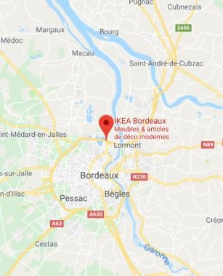 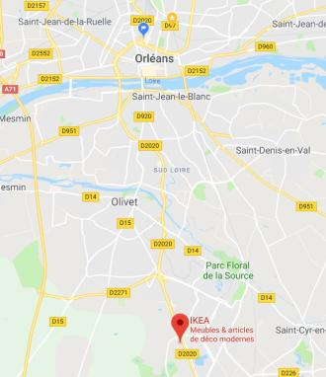

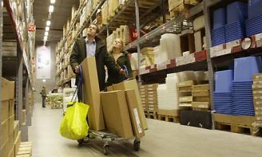 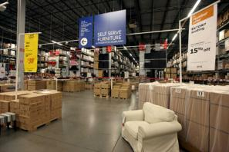

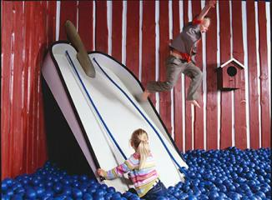

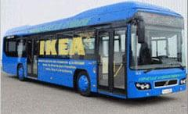 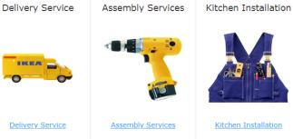

**Travail personnel.**

En étudiant ce cas d’étude, et vous inspirant des photos (mais aussi d’autres ressources que vous pouvez trouver sur le net), prenez le temps de réfléchir aux différentes techniques utilisées par Ikea pour devenir le géant qu’il est devenu. Une source infinie d’inspirations.