# Third lecture (Ch 4)

## N° 1 – Inteli corp.

Every year it was the same. All the workstations in the building had to be renovated (tested, new software installed, etc.) and there was only one week in which to do it. The one week fell in the middle of the August vacation period when the renovation process would cause minimum disruption to normal working. Last year the company’s 500 work-stations had all been renovated within one working week (40 hours). Each renovation last year took on average two hours. This year there would be 530 workstations to renovate but the company’s IT support unit had devised a faster testing and renovation routine that would only take on average one and a half hours instead of two hours. How many technicians will be needed this year to complete the renovation processes within the week?

## N° 2 – Vehicle licencing

A vehicle licensing centre receives application documents, keys in details, checks the information provided on the application, classifies the application according to the type of licence required, confirms payment and then issues and mails the licence. It is currently processing an average of 5000 licences every eight-hour day. A recent spot check found 15,000 applications that were in progress or waiting to be processed. The sum of all activities required to process an application is 25 minutes.

### Questions de reflexion

## What is the throughput efficiency of the process?

1. Of the 25 minutes of work content, only 20 minutes was actually adding value. What is the value-added throughput efficiency?

## N° 3 – Business process re-engineering

Les deux cartographies de processus suivants représentent un même processus avant et après une ré-ingénierie de processus.

Analyser ces deux processus et répondre aux questions du TD.

**“Baseline” Time-Function Map**

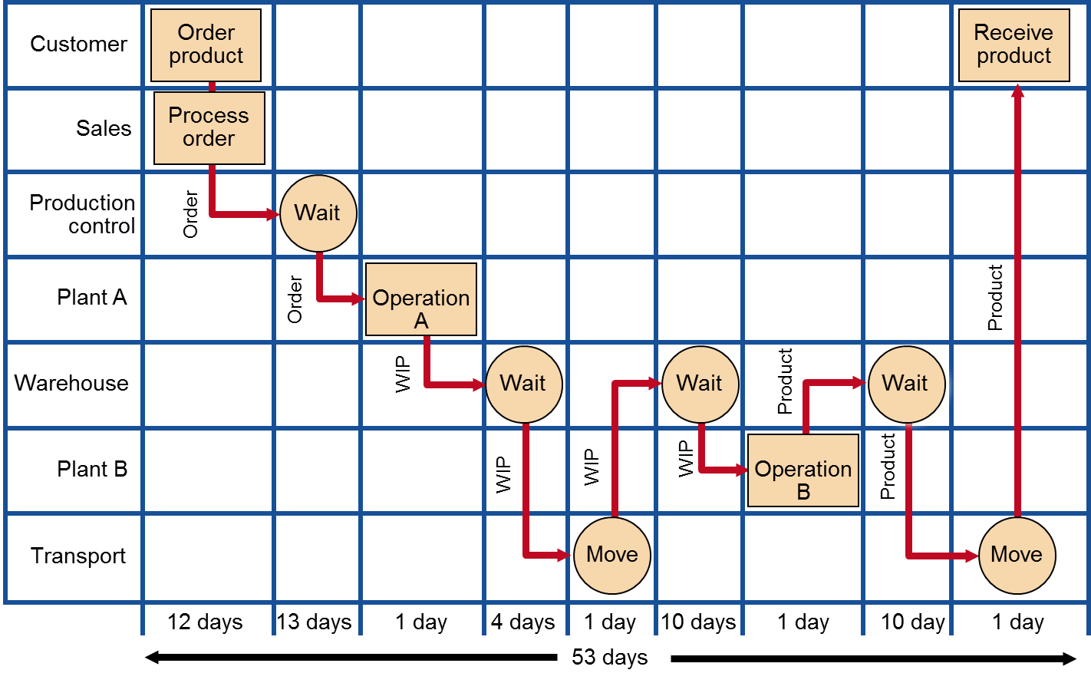

**“Target” Time-Function Map**

